**APPLIED STATITICS LAB**

**WEEK-3**

NAME: SRIJITH U

REG NO : 22BCE8916

Matrix

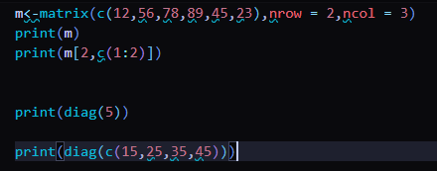

Output:

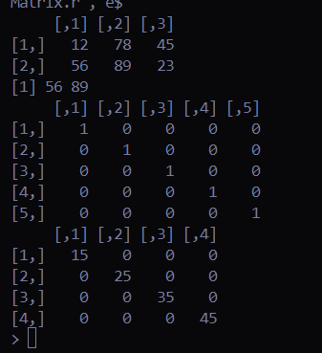

Data Structures

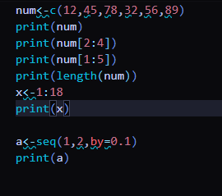

Output:

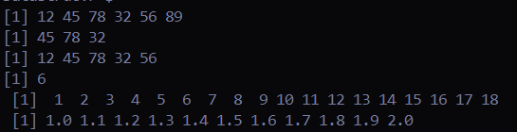

Data Frames

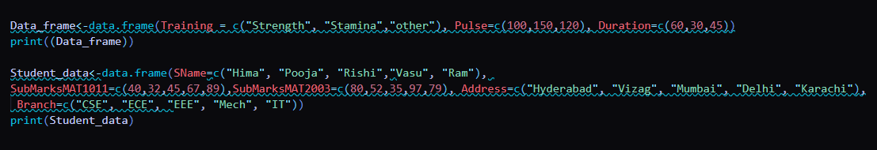

Output:

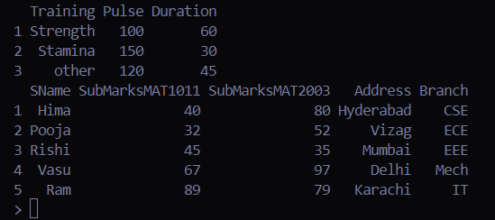

Graph

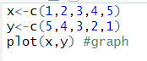

Output:

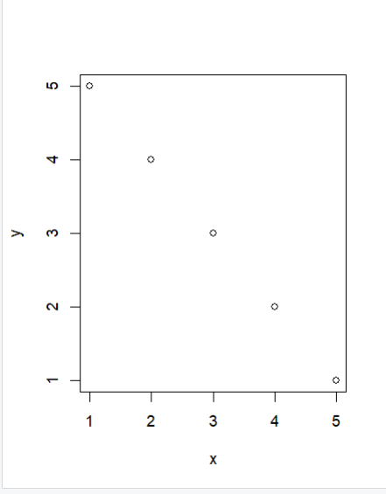

Pie Chart



Output:

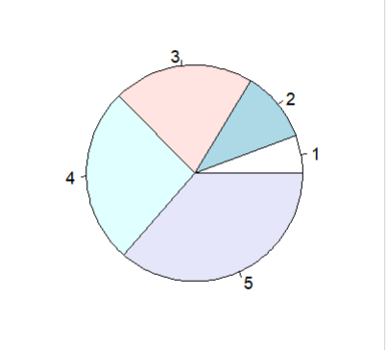

Bar plot

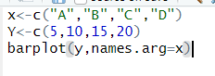

Output:

